import pandas as pd
import numpy as np
import seaborn as sns
import matplotlib.pyplot as plt
from sklearn.metrics import roc_curve, auc
import warnings
warnings.filterwarnings(action="ignore")
from sklearn.model_selection import train_test_split
from sklearn.metrics import accuracy_score, classification_report
from sklearn.ensemble import AdaBoostClassifier
from sklearn.neural_network import BernoulliRBM
from sklearn.preprocessing import StandardScaler
from imblearn.over_sampling import SMOTE
import tensorflow as tf
from tensorflow.keras.models import Sequential
from tensorflow.keras.layers import Dense
from tensorflow.keras.layers import LSTM
from sklearn.metrics import roc_curve, auc
from sklearn import metrics
from sklearn.metrics import confusion_matrix
from sklearn.datasets import make_classification
from sklearn.metrics import accuracy_score, precision_score, recall_score, f1_score
#importing data from the dataset
df = pd.read_csv(r"C:\Users\agarw\OneDrive\Desktop\Dissertation\data.csv")
#checking for bankrupt companies 0 is non-bankrupt and 1 is bankrupt
bankrupt_data = df['Bankrupt?'].value_counts()
bankrupt_data
Bankrupt?
0 6599
1 220
Name: count, dtype: int64
plt.figure(figsize = (10,5))
colors = ["#3498db", "#e74c3c"]
ax = sns.countplot(x=df['Bankrupt?'], data=df,palette=colors)
for p in ax.patches:
ax.annotate(f'{p.get_height()}', (p.get_x() + p.get_width() / 2., p.get_height()),
ha='center', va='center', xytext=(0, 10), textcoords='offset points')
# Add labels and title
plt.xlabel('Bankrupt')
plt.ylabel('Count')
plt.title('Distribution of Bankrupt')
# Show the plot
plt.show()
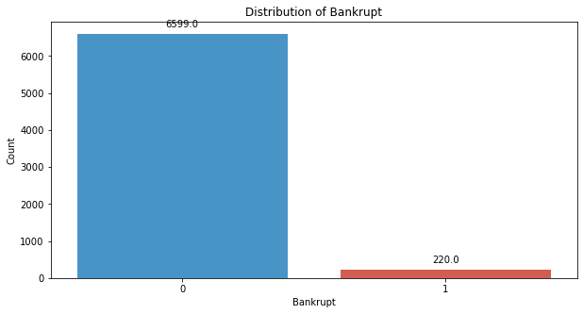
# seperate the Bankrupt label from the dataset
y = df['Bankrupt?']
X = df.drop(['Bankrupt?'], axis = 1)
# divinding our dataset into training dataset
X_train, X_temp, y_train, y_temp = train_test_split(X, y, test_size=0.2, random_state=42)
plt.figure(figsize = (10,5))
colors = ["#3498db", "#e74c3c"]
ax = sns.countplot(x=y_train, data=df,palette=colors)
for p in ax.patches:
ax.annotate(f'{p.get_height()}', (p.get_x() + p.get_width() / 2., p.get_height()),
ha='center', va='center', xytext=(0, 10), textcoords='offset points')
# Add labels and title
plt.xlabel('Bankrupt')
plt.ylabel('Count')
plt.title('Distribution of Bankrupt')
# Show the plot
plt.show()
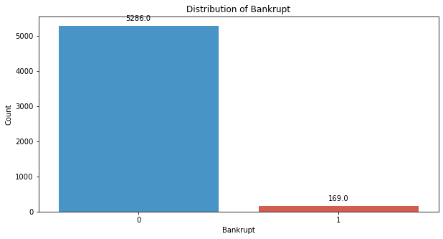
# divinding our dataset into testing and validation
X_val, X_test, y_val, y_test = train_test_split(X_temp, y_temp, test_size=0.5, random_state=42)
smote = SMOTE(sampling_strategy=0.5, random_state=42)
X_train_resampled, y_train_resampled = smote.fit_resample(X_train, y_train)
plt.figure(figsize = (10,5))
colors = ["#3498db", "#e74c3c"]
ax = sns.countplot(x=y_train_resampled, data=df,palette=colors)
for p in ax.patches:
ax.annotate(f'{p.get_height()}', (p.get_x() + p.get_width() / 2., p.get_height()),
ha='center', va='center', xytext=(0, 10), textcoords='offset points')
# Add labels and title
plt.xlabel('Bankrupt')
plt.ylabel('Count')
plt.title('Distribution of Bankrupt')
# Show the plot
plt.show()
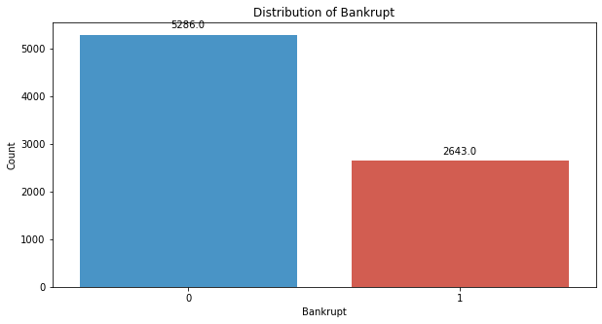
# Standardize the data
scaler = StandardScaler()
X_train_resampled = scaler.fit_transform(X_train_resampled)
X_val = scaler.transform(X_val)
X_test = scaler.transform(X_test)
# Step 4: Build the MLP model
model = tf.keras.Sequential([
tf.keras.layers.Dense(128, activation='relu', input_shape=(X_train_resampled.shape[1],)),
tf.keras.layers.Dropout(0.5),
tf.keras.layers.Dense(64, activation='relu'),
tf.keras.layers.Dropout(0.5),
tf.keras.layers.Dense(32, activation='relu'),
tf.keras.layers.Dropout(0.5),
tf.keras.layers.Dense(16, activation='relu'),
tf.keras.layers.Dropout(0.5),
tf.keras.layers.Dense(8, activation='relu'),
tf.keras.layers.Dropout(0.5),
tf.keras.layers.Dense(1, activation='sigmoid')
])
model.compile(optimizer='adam', loss='binary_crossentropy', metrics=['accuracy'])
model.fit(X_train_resampled, y_train_resampled, epochs=25, batch_size=32, verbose = 2)
Epoch 1/25
248/248 - 2s - 7ms/step - accuracy: 0.6404 - loss: 0.6546
Epoch 2/25
248/248 - 0s - 2ms/step - accuracy: 0.7164 - loss: 0.4606
Epoch 3/25
248/248 - 0s - 1ms/step - accuracy: 0.8340 - loss: 0.3809
Epoch 4/25
248/248 - 0s - 1ms/step - accuracy: 0.8608 - loss: 0.3445
Epoch 5/25
248/248 - 0s - 1ms/step - accuracy: 0.8861 - loss: 0.2891
Epoch 6/25
248/248 - 0s - 1ms/step - accuracy: 0.8932 - loss: 0.2728
Epoch 7/25
248/248 - 0s - 1ms/step - accuracy: 0.9078 - loss: 0.2505
Epoch 8/25
248/248 - 0s - 1ms/step - accuracy: 0.9169 - loss: 0.2211
Epoch 9/25
248/248 - 0s - 1ms/step - accuracy: 0.9194 - loss: 0.2131
Epoch 10/25
248/248 - 0s - 1ms/step - accuracy: 0.9242 - loss: 0.2036
Epoch 11/25
248/248 - 0s - 2ms/step - accuracy: 0.9280 - loss: 0.1992
Epoch 12/25
248/248 - 0s - 1ms/step - accuracy: 0.9314 - loss: 0.1890
Epoch 13/25
248/248 - 0s - 1ms/step - accuracy: 0.9354 - loss: 0.1918
Epoch 14/25
248/248 - 0s - 1ms/step - accuracy: 0.9411 - loss: 0.1696
Epoch 15/25
248/248 - 0s - 1ms/step - accuracy: 0.9436 - loss: 0.1650
Epoch 16/25
248/248 - 0s - 1ms/step - accuracy: 0.9440 - loss: 0.1560
Epoch 17/25
248/248 - 0s - 1ms/step - accuracy: 0.9455 - loss: 0.1643
Epoch 18/25
248/248 - 0s - 1ms/step - accuracy: 0.9518 - loss: 0.1417
Epoch 19/25
248/248 - 0s - 1ms/step - accuracy: 0.9506 - loss: 0.1427
Epoch 20/25
248/248 - 0s - 1ms/step - accuracy: 0.9546 - loss: 0.1380
Epoch 21/25
248/248 - 0s - 1ms/step - accuracy: 0.9560 - loss: 0.1327
Epoch 22/25
248/248 - 0s - 1ms/step - accuracy: 0.9552 - loss: 0.1352
Epoch 23/25
248/248 - 0s - 1ms/step - accuracy: 0.9580 - loss: 0.1295
Epoch 24/25
248/248 - 0s - 1ms/step - accuracy: 0.9565 - loss: 0.1289
Epoch 25/25
248/248 - 0s - 1ms/step - accuracy: 0.9570 - loss: 0.1222
<keras.src.callbacks.history.History at 0x1dc08445eb0>
y_pred_val = (model.predict(X_val) > 0.5).astype(int)
22/22 ━━━━━━━━━━━━━━━━━━━━ 0s 2ms/step
# Evaluate the model's performance on the Validation set
val_accuracy = accuracy_score(y_val, y_pred_val)
precision = precision_score(y_val, y_pred_val)
recall = recall_score(y_val, y_pred_val)
f1_value = f1_score(y_val, y_pred_val)
val_report = classification_report(y_val, y_pred_val)
print("Accuracy", val_accuracy)
print("Precision", precision)
print("Recall", recall)
print("F1 Score", f1_value)
print("Validation Classification Report:\n", val_report)
Accuracy 0.9398826979472141
Precision 0.2765957446808511
Recall 0.65
F1 Score 0.3880597014925373
Validation Classification Report:
precision recall f1-score support
0 0.99 0.95 0.97 662
1 0.28 0.65 0.39 20
accuracy 0.94 682
macro avg 0.63 0.80 0.68 682
weighted avg 0.97 0.94 0.95 682
conf_matrix = confusion_matrix(y_val, y_pred_val)
print("Confusion Matrix")
print(conf_matrix)
Confusion Matrix
[[628 34]
[ 7 13]]
y_pred_test = (model.predict(X_test) > 0.5).astype(int)
22/22 ━━━━━━━━━━━━━━━━━━━━ 0s 774us/step
# Evaluate the model's performance on the Validation set
val_accuracy = accuracy_score(y_test, y_pred_test)
precision = precision_score(y_test, y_pred_test)
recall = recall_score(y_test, y_pred_test)
f1_value = f1_score(y_test, y_pred_test)
val_report = classification_report(y_test, y_pred_test)
print("Accuracy", val_accuracy)
print("Precision", precision)
print("Recall", recall)
print("F1 Score", f1_value)
print("Validation Classification Report:\n", val_report)
Accuracy 0.9369501466275659
Precision 0.35
Recall 0.45161290322580644
F1 Score 0.3943661971830986
Validation Classification Report:
precision recall f1-score support
0 0.97 0.96 0.97 651
1 0.35 0.45 0.39 31
accuracy 0.94 682
macro avg 0.66 0.71 0.68 682
weighted avg 0.95 0.94 0.94 682
conf_matrix = confusion_matrix(y_test, y_pred_test)
print("Confusion Matrix")
print(conf_matrix)
Confusion Matrix
[[625 26]
[ 17 14]]
# Compute ROC curve and ROC area for each class
fpr_val, tpr_val, _ = roc_curve(y_val, y_pred_val)
roc_auc_val = auc(fpr_val, tpr_val)
fpr_test, tpr_test, _ = roc_curve(y_test, y_pred_test)
roc_auc_test = auc(fpr_test, tpr_test)
# Plot ROC curve
plt.figure(figsize=(8, 8))
plt.plot(fpr_val, tpr_val, color='darkorange', lw=2, label=f'Validation ROC curve (area = {roc_auc_val:.2f})')
plt.plot(fpr_test, tpr_test, color='green', lw=2, label=f'Test ROC curve (area = {roc_auc_test:.2f})')
plt.plot([0, 1], [0, 1], color='navy', lw=2, linestyle='--')
plt.xlim([0.0, 1.0])
plt.ylim([0.0, 1.05])
plt.xlabel('False Positive Rate')
plt.ylabel('True Positive Rate')
plt.title('Receiver Operating Characteristic (ROC) Curve')
plt.legend(loc="lower right")
plt.show()
